Printing Employee 1095-C Forms & Creating AIR File for IRS

To Print Employees’ 1095-C Forms:
Verify employees who should receive a 1095-C have data. From Personnel > Payroll Information Reports > 1095-C Forms (HRS5255). Enter the following report parameters.
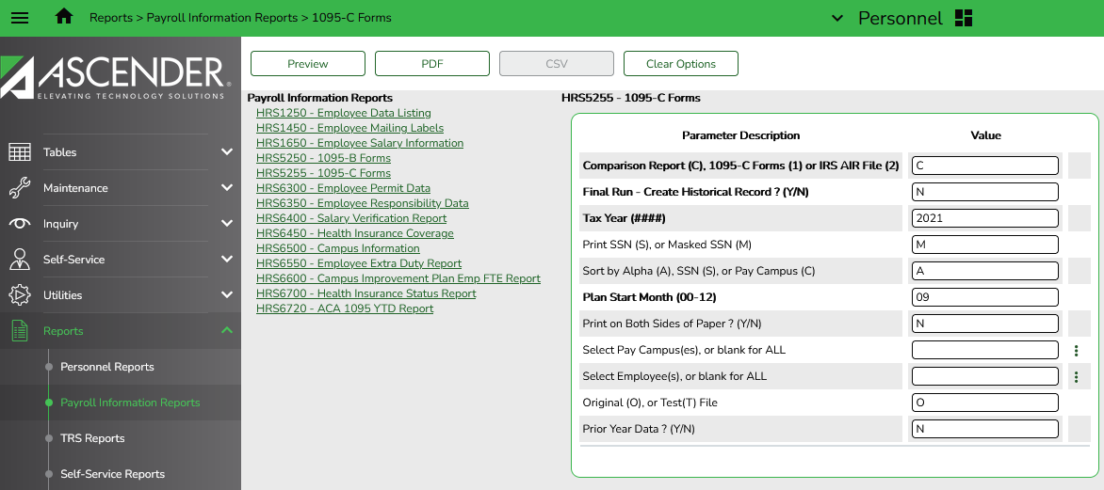
The comparison report will show employees who are receiving a W-2 and then indicate whether they also have data and will receive a 1095-C. Most employees will show Yes in both columns. Verify those that show No in the 1095-C are employees or subs who did not work full-time.
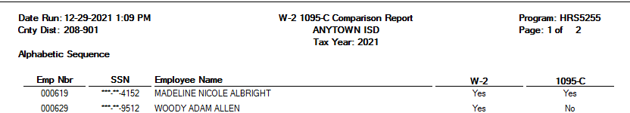
If employee worked enough hours to qualify for health insurance and therefore should receive a 1095-C, enter data manually from Maintenance > ACA 1095 YTD Data > 1095-C tab. Remember to enter the data for Calendar Year 2021.
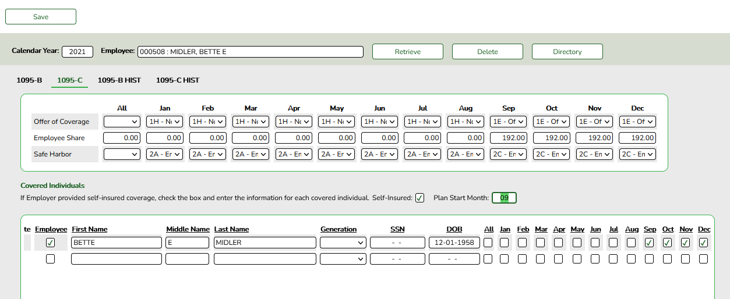
Once all applicable employees show correctly on the Comparison Report, return to Personnel > Payroll Information Reports > 1095-C Forms (HRS5255) and run the report with the following parameters.
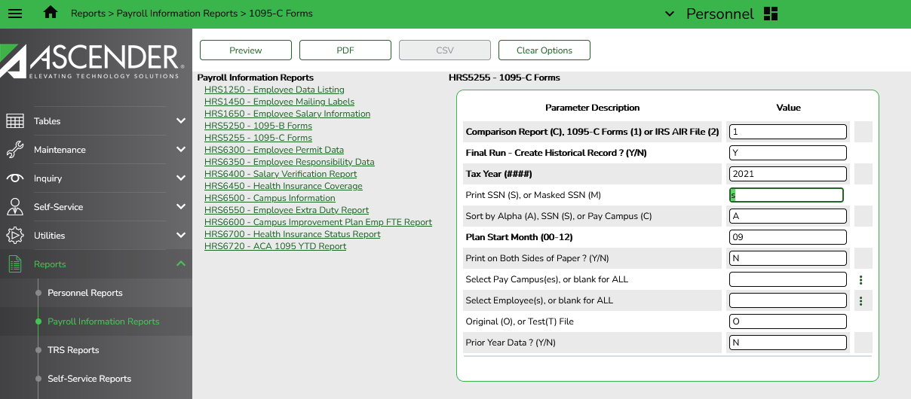
The forms will contain instructions as the second page. If you have a printer that can easily print front to back, print that way. If not, just know that every other page will contain instructions and you’ll want to give each employee 2 sheets of paper.

If you use Employee Portal to distribute 1095-C forms to your employees, complete the following step as well. From Payroll > Tables > District EP Options, check the box under Enable for 1095 Information. Note: If 1095 Electronic Consent is checked, you will not be able to print the form for them. The employee will be limited to receiving the form through Employee Portal.
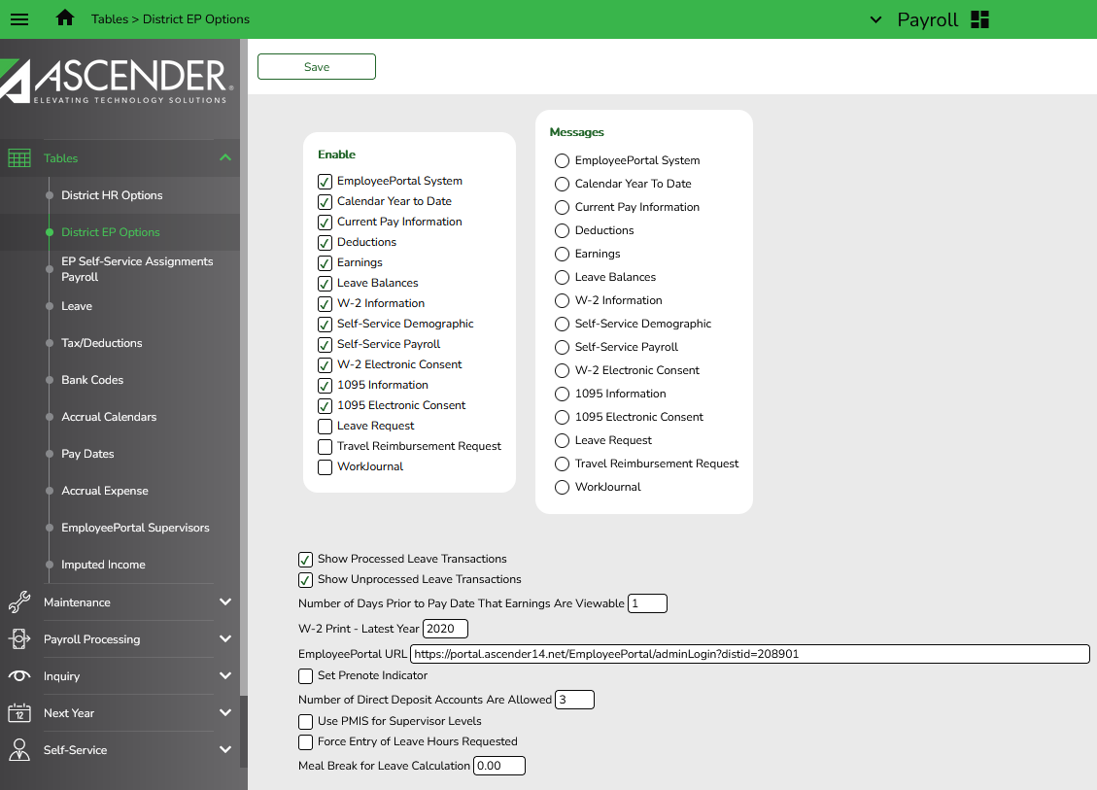

Note: Before sending the AIR file to the IRS, you must complete the 1094 data. This serves as a coversheet for the forms. We have a separate document for these steps.

